Introduction to R Markdown

January 12, 2016

This is a brief introduction to R Markdown.

**Note**: In order to compile the RMarkdown document, save the following files to the same folder as [this document](http://my.ilstu.edu/~wjschne/442/Introduction%20to%20RMarkdown.Rmd):

* [APA.docx](http://my.ilstu.edu/~wjschne/442/APA.docx) This file is a template to create MS Word documents in APA Style. The template is a work in progress and thus does not get everything exactly right.
* [APAStyle.css](http://my.ilstu.edu/~wjschne/442/APAStyle.css) This file provides APA-like styling for HTML output. You can make .css files to format text and other HTML elements in almost any way you want.
* [apa.csl](http://my.ilstu.edu/~wjschne/442/apa.csl) This file tells R Markdown how to format citations in APA Style.
* [citations.bib](http://my.ilstu.edu/~wjschne/442/citations.bib) This file contains a few citations in BibTeX format.

# R Markdown

[Markdown](http://daringfireball.net/projects/markdown/basics) is a really simple way to format documents. [R Markdown](http://rmarkdown.rstudio.com/) is a variant of Markdown that works in [RStudio](http://www.rstudio.com/).

# This is a Level 1 header

This is a regular paragraph. Extra spaces between words are eliminated. Even though this sentence is broken across many lines, it is grouped with the text above it.

Put an empty line between paragraphs.

You can't see them but if you put 2 or more spaces  
at the end  
of a line,  
there is a line break.

## This is a Level 2 header

### Guess which level header this is!

# Formatting text

*This is italicized.*

**This is bolded.**

~~Strikethrough~~

Superscript2

This is for blockquotes. It can go on for many lines.

This is the second paragraph in a blockquote. In my .css file, I have formatted it so that it will be indented.

Text enclosed in three backquotes (```) will appear in a monospace type. It will appear exactly   
as  
 you   
 type it,  
without the typical formatting.  
  
For example,  
*normally this would be italicized.*

# Lists

Let's make an unordered list

* First bullet point
* Second bullet point
  + Indented bullet point (2 tabs or 4 spaces)
  + Another indented bullet point
    - Further indentation (4 tabs or 8 spaces)

Let's make an ordered list

1. My first topic
   1. Sub topic 1
   2. Sub topic 2
2. My second topic
   * Subtopic (2 tabs or 4 spaces)
   * Another subtopic  
     This is a indented paragraph in the middle of a list (2 tabs or 4 spaces).
   * Yet another subtopic
3. My third topic

# Links

[This is a link to my homepage.](http://my.ilstu.edu/~wjschne/)

# Images

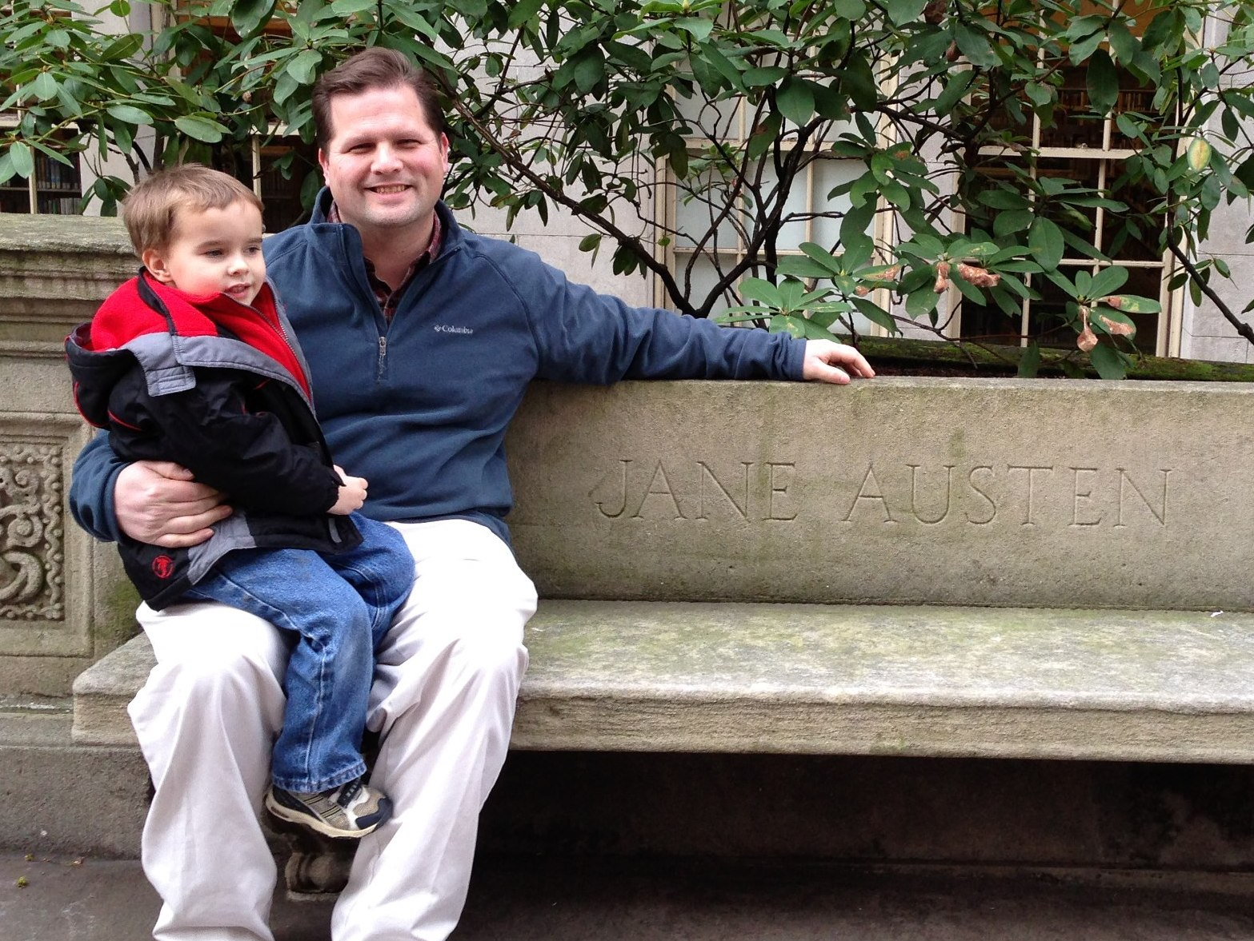

# Equations using $\LaTeX$

# Simple Tables

|  |  |  |
| --- | --- | --- |
| Left | Center | Right |
| 1 | 2 | 3 |
| 4 | 5 | 6 |
| 7 | 8 | 9 |

# Combining R and Markdown

## R code chunks

EvenNumbersUnder100<-seq(2,98,2)

This code chunk will run but it will not appear in the document.

This code chunk will appear in the document but it will not run.

Y<-tan(pi/4)

## Inline R code

You can refer to calculations in your text. For example, the cosine of radians is -1. In fact, you can refer to any R object (e.g., the mean and standard deviation of a variable.)

## Let's make a pretty plot with R:

par(family = "serif")  
x <- 0:20  
y <- dpois(x,lambda = 3)  
plot(y~x,type="b",col="royalblue2",lty=3,pch=19,main=expression("Poisson Distribution "*(lambda == 3)),xlab="Sample Space",ylab="Probability",bty="n",las=1)



## APA Formatted tables!

n<-1000 #Sample size  
g<-rnorm(n) #Normal variate  
s1<-g+rnorm(n) #Correlated variate  
s2<-g+rnorm(n) #Correlated variate  
d<-cbind(g,s1,s2) #Bind columns into a matrix  
dcor<-round(cor(d),2) #Correlation matrix (rounded to 2 digits)  
dcor[lower.tri(dcor,diag=TRUE)]<-"" #Remove lower triangle  
knitr::kable(dcor,align = "c") #Make table with centered columns

|  |  |  |  |
| --- | --- | --- | --- |
|  | g | s1 | s2 |
| g |  | 0.72 | 0.68 |
| s1 |  |  | 0.49 |
| s2 |  |  |  |

# Citations

As explained [here](http://rmarkdown.rstudio.com/authoring_bibliographies_and_citations.html), if you use the bibliography tag, you can insert citations with the @ symbol and the citation's unique ID. A variety of citation file formats are supported and a huge number of citation styles are [available](https://zotero.org/styles). I am using the [BibTeX file format](http://www.bibtex.org/) with the [APA (6th Edition) citation style](https://zotero.org/styles/apa).

For example, here are some recent papers of mine (Kahn & Schneider, 2013; Schneider, 2013a). In this paper, Schneider (2013b, pp. 186–187) says a bunch of stuff.

Tools like these make managing references much, much easier than doing it all by hand. The references below appear like magic, all perfectly formatted.

# References

Kahn, J. H., & Schneider, W. J. (2013). It’s the destination and it’s the journey: Using multilevel modeling to assess patterns of change in psychotherapy. *Journal of Clinical Psychology*, *69*(6), 543–570.

Schneider, W. J. (2013a). Principles of assessment of aptitude and achievement. In D. Saklofske, C. Reynolds, & V. Schwean (Eds.), *The Oxford handbook of child psychological assessment* (pp. 286–330). New York: Oxford University Press.

Schneider, W. J. (2013b). What if we took our models seriously? Estimating latent scores in individuals. *Journal of Psychoeducational Assessment*, *31*(2), 186–201.